**MATRIC_NO:** 207189

**COURSE_CODE:** 332

**COURSE_TITLE:** SURVEY OF PROGRAMMING (PRACTICAL II).

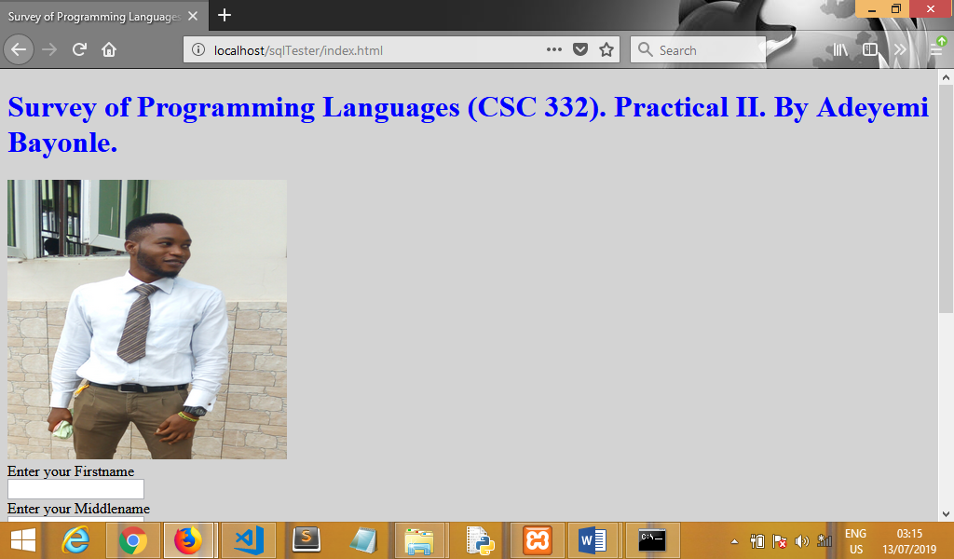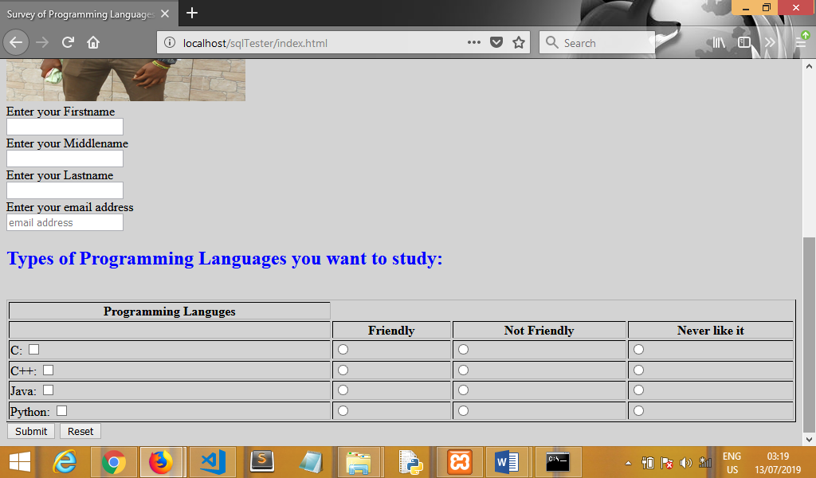**The Website Image.**

**The Database That Accept The Person’s Information.**

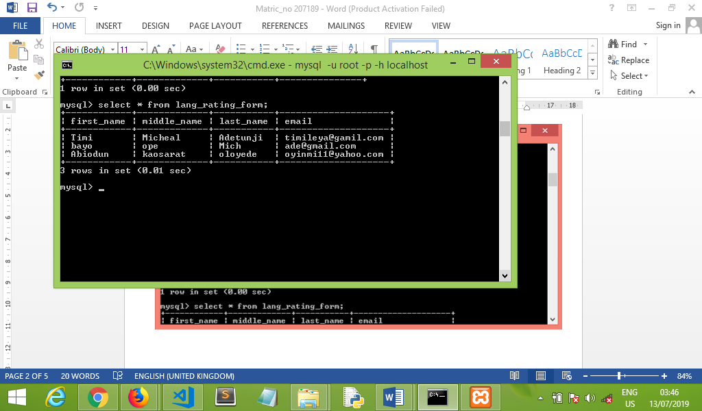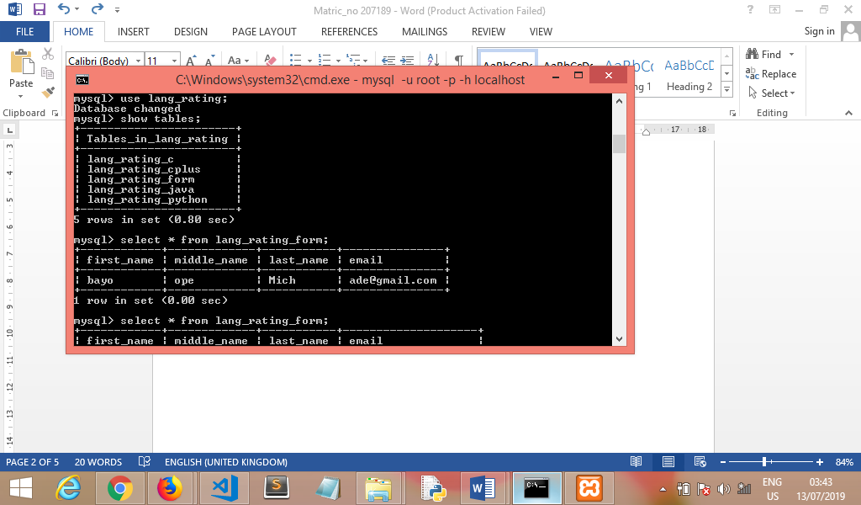

**Html code.**

<!DOCTYPE html>

<html>

<head>

    <title>Survey of Programming Languages by Adeyemi_Bayo</title>

    <!--Adeyemi_Bayo Monday 15th,2019 11:59pm -->

</head>

<body style="background-color:lightgrey;">

<h1 style="color: blue;">Survey of Programming Languages (CSC 332). Practical II. By Adeyemi Bayonle. </h1>

        <img src="Myimage.png" width="300" height="300"><br>

<form action="file.php" method="POST">

Enter your Firstname <br>

<input type="text" name="fname"> <br>

Enter your Middlename <br>

<input type="text" name="mname"> <br>

Enter your Lastname <br>

<input type="text" name="lname"> <br>

Enter your email address <br>

<input type="email" placeholder="email address" name="email_address">   <br>

<b><h2 style="color: blue;">Types of Programming Languages you want to study:</b></h2> <br>

            <table border="1" style="width:100%">

                <thead>

                    <tr>

                        <th>

                            Programming Languges

                            </th>

                    </tr>

                    <tr>

                        <th></th>

                        <th>Friendly

                            </th>

                        <th>Not Friendly

                            </th>

                        <th>Never like it

                            </th>

                    </tr>

                </thead>

                <tbody>

                    <!--form-->

                        <tr>

                            <td>

                                C:

                                <input type="checkbox" value= "language">

                            </td>

                            <td>

                                <input type="radio" name= "Radc" value= "Friendly">

                            </td>

                            <td>

                                <input type="radio" name="Radc" value= "Not_Friendly">

                            </td>

                            <td>

                                <input type="radio" name= "Radc" value= "Never_like_it">

                            </td>

                        </tr>

                        <tr>

                            <td>

                                C++:

                                <input type="checkbox" value= "language">

                            </td>

                            <td>

                                <input type="radio" name= "Rad" value= "Friendly">

                            </td>

                            <td>

                                <input type="radio" name="Rad" value= "Not_Friendly">

                            </td>

                            <td>

                                <input type="radio" name= "Rad" value= "Never_like_it">

                            </td>

                        </tr>

                        <tr>

                            <td>

                                Java:

                                <input type="checkbox" value= "language">

                            </td>

                            <td>

                                <input type="radio" name= "Radj" value= "Friendly">

                            </td>

                            <td>

                                <input type="radio" name="Radj" value= "Not_Friendly">

                            </td>

                            <td>

<input type="radio" name= "Radj" value= "Never_like_it

">

                            </td>

                        <tr>

                            <td>

                                Python:

                                <input type="checkbox" value= "language" >

                            </td>

                            <td>

                                <input type="radio" name= "Radp" value= "Friendly">

                            </td>

                            <td>

                                <input type="radio" name="Radp" value= "Not_Friendly">

                            </td>

                            <td>

                                <input type="radio" name= "Radp" value= "Never_like_it">

                            </td>

                        </tr>

                    </form>

                </tbody>

            </table>

          <input type="Submit" value="Submit" onclick="">

            <input type="reset" value="Reset" onclick="">

</form>

</body>

</html>

**Php code connecting to Database.**

<?php

$servername = "localhost";

$username = "root";

$password = "";

$dbname = "lang_rating";

//database connection

$link = mysqli_connect($servername, $username, $password, $dbname);

// Check connection

if($link === false){

die("ERROR: Could not connect. " . mysqli_connect_error());

}

$sql="INSERT INTO lang_rating_form (first_name, middle_name, last_name, email)

VALUES ('$_POST[fname]','$_POST[mname]','$_POST[lname]','$_POST[email_address]')";

$sql1="INSERT INTO lang_rating_c (email, radC)

VALUES ('$_POST[email]','$_POST[radC]')";

$sql2="INSERT INTO lang_rating_cplus (email, rad)

VALUES ('$_POST[email]','$_POST[rad]')";

$sql3="INSERT INTO lang_rating_java (email, radj)

VALUES ('$_POST[email]','$_POST[radj]')";

$sql4="INSERT INTO lang_rating_python (email, radp)

VALUES ('$_POST[email]','$_POST[radp]')";

if(mysqli_query($link, $sql) && mysqli_query($link, $sql1) && mysqli_query($link, $sql2) && mysqli_query($link, $sql3) && mysqli_query($link, $sql4)){

echo "Records inserted successfully.";

} else{

echo "ERROR: Could not able to execute $sql. " . mysqli_error($link);

}

mysqli_close($link);

?>